Tandylyn Cooke Biography
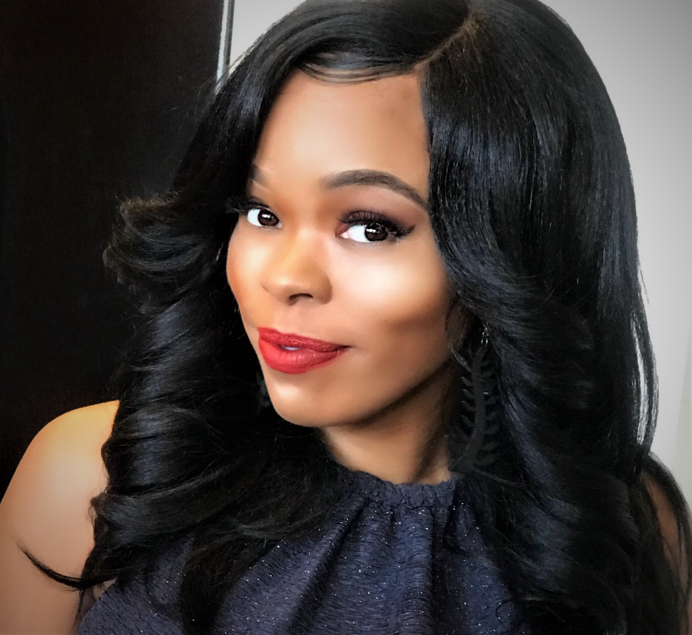
Tandylyn Cooke acquired two undergraduate degrees that consist of an Associates in Computer Science at J. Sargeant Reynolds in Richmond, Virginia and a Bachelors in Business Admin at Strayer University in Glen Allen, Virginia. She also acquired her Masters of Business Administration with a focus on innovative leadership at Stratford University in Glen Allen, Virginia. Tandylyn’s heart passions are driven by her love for knowledge and the art of sharing knowledge in efforts to counteract the elements of perishing, through artistic channels. Tandylyn spends a tremendous amount of time engaging in community services initiatives that includes the donation of time, money, and resources. During both middle and high school seasons, Tandylyn mentor students ranging from 15 to 18 years of age each week through the Team Excel Foundation created by former NFL player Michael Robinson. She serves as a sounding board for concerns for each student regarding academics, athleticism, and social environments, in which she offers sound solutions, along with posing thought provoking questions that challenges her mentees to critically think about the world in which they live. Tandylyn mentoring strategies are designed to link the gaps between historical foot prints and paths, with the current mental makeup of the youth and the forever changing position of society. Tandylyn has also appeared as a reoccurring voice/speaker on Legacy Internet Radio, a panel speaker on a talk show titled “Sista to Sista… Can we talk?” own by the Legendary Author Mrs. Tracey Hardney-Scott, guest speaker on Nigeria (Enugu State) Soul Sista radio show, and Co-host on the Jagar & Diamond Tee radio show (WRIR 97.3FM). Each social platform embodied and focused on community relationships/efforts, political environments, musical influencers, black independent films, and societal challenges. Tandylyn is also an evolving actress, in which she will continue to display various hidden talents of bringing ones’ written work to life through the channel of theatrical arts. Tandylyn is known for her devoted love for her African Nigerian roots and combination of several other African tribes, in which she draws strength from ancestral memory, documented and undocumented lessons that has been passed down through her direct ancestral lineage. Her mantra on life encompasses love, belief, family, and comprehension of the overall collective human experience.

